**Jharkhand**

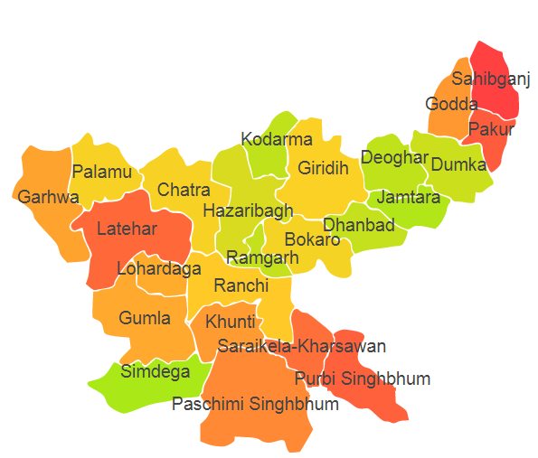

Jharkhand comprises of four Agro Ecological Regions (AER) 11,12,13 and 15.

**Agro-Eco Region 11:** AER 11 in Jharkhand comprises of Chatra, Garhwal, Gumla, Hazaribagh, Kodarma, Latehar, Lohardaga, Palamu, Simdega and Ranchi districts of Eastern Plateau under Agro Ecological Sub Region (AESR) 11.

**Agro-Eco Region 12:** AER12 in Jharkhand comprises of Bokaro, Devgarh, Dhanbad, Dumka, Giridih, Jamtara, Kunti, Pakur, Paschim Singhbhumi, Purbi Singhbhumi, Ranchi, Ramgarh, Sahebganj and Saraikela districts of Eastern Plateau and Eastern Ghats under Agro Ecological Sub Region (AESR) 12.3.

**Agro-Eco Region 13:** AER 13 in Jharkhand comprises of Gooda and Sahebganj districts of Eastern Plain under Agro Ecological Sub Region (AESR) 13.1.

**Agro-Eco Region 15:** AER15 in Jharkhand comprises of Pakur and Sahebganj districts of Bengal and Assam Plain under Agro Ecological Sub Region (AESR) 15.1.